|  |
| --- |
| ***Where the risk is extreme or high, do not attempt the activity until additional controls are put in place to reduce the risk to medium or low.***  ***Undertake ongoing dynamic assessments throughout the activity. If the risk increases to high or extreme, stop and reassess. If the job can’t be done safely refer the job to the responsible authority.*** |
| |  |  | | --- | --- | | **Activity name / RFA no.** |  | | **Activity / RFA location** |  | | **Activity date(s)** |  | |
|  |

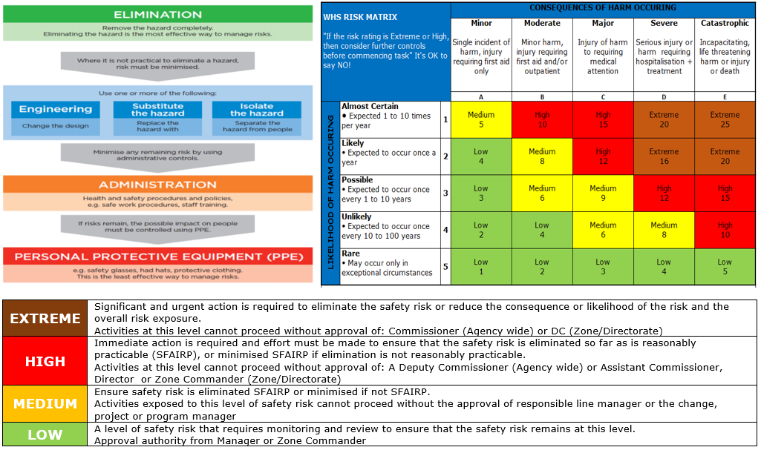

|  |  |  |  |  |  |  |  |
| --- | --- | --- | --- | --- | --- | --- | --- |
| **HAZARD ID** | **RISK ASSESSMENT** | | | **CONTROL AND REVIEW** | | | |
| **Hazard Description** | **Consequence**  A,B,C,D or E | **Likelihood**  1,2,3,4 or 5 | **Risk Rating**  E,H,M or L | **Control Measures** | **New Consequence**  A,B,C,D or E | **New Likelihood**  1,2,3,4 or 5 | **Residual Risk Rating**  E,H,M or L |
| ***Eg: Using ladder(s) onsite – fall from*** | ***C*** | ***4*** | ***Medium*** | ***Ensure three points at all times at minimum*** | ***D*** | ***5*** | ***Low*** |
|  |  |  |  |  |  |  |  |
|  |  |  |  |  |  |  |  |
|  |  |  |  |  |  |  |  |
|  |  |  |  |  |  |  |  |
|  |  |  |  |  |  |  |  |
|  |  |  |  |  |  |  |  |
|  |  |  |  |  |  |  |  |
|  |  |  |  |  |  |  |  |
|  |  |  |  |  |  |  |  |
|  |  |  |  |  |  |  |  |
| **Participants Names:** | | | **Team Leader/Manager name: Date:**  **Position Title: Signature:** | | | | |

This form must be completed prior to undertaking any task that does not involve an immediate threat to life.