# BREWARRINA

MRNSW VOLUNTEER FLOOD RESPONSE DEPLOYMENT – ENVIRONMENT AWARENESS INFORMATION

# Contents

[1 Duties 1](https://docs.google.com/document/d/1lPgzVKFZRTaA8RMzlujyOdOidMd3PJyBx8bpf5KlEAM/edit#heading=h.30j0zll)

2 HQ Support 2

3 Arrival, Departure and Administration 2

4 Safety, First Aid and PPE 3

5 Sleeping and Bedding Arrangements 5

6 Fuel, Cars and Parking 5

7 Food and Beverages 5

8 Clothing 6

9 Sanitation, Hygiene and Sun Safety 6

10 Technology 6

11 Employment Protection Letter 6

[12](https://docs.google.com/document/d/1lPgzVKFZRTaA8RMzlujyOdOidMd3PJyBx8bpf5KlEAM/edit#heading=h.26in1rg)  [Parkes Base Camp Photos](https://docs.google.com/document/d/1lPgzVKFZRTaA8RMzlujyOdOidMd3PJyBx8bpf5KlEAM/edit#heading=h.lnxbz9) 7

## 

## 

## Firstly, thank you for volunteering to support the State Emergency Service (SES) and other emergency service partners in providing assistance to those affected by the latest flooding event in NSW. It is hoped that these joining instructions will give you some situational awareness of the environment you will be operating in, and provide you with necessary information. It is also important to ensure that you are properly briefed whenever you are deployed during this flood event, whether that be by the local SES or whomever is coordinating the flood response within your tasked area. Operating in flood waters comes with inherent risks so please ensure you are keeping yourself and those on your team safe at all times. MRNSW members must also ensure they wear appropriate PPE and follow MRNSW SOPS.

## Duties

Deployment tasks vary from day-to-day, depending upon the pressing need in the location. This may include, but not be limited to, onshore tasks such as filling/distributing sandbags, and transporting provisions, to on-water rescues, providing resupply to isolated residents, or transporting people from A to B etc.

Some tasks our crews have undertaken so far are below:

* Being on standby to assist with any sudden on-water emergencies
* Using a MRNSW or other agency vessels or vehicles to conduct reconnaissance, evacuate people, transport people for medical treatment, transport supplies and move livestock
* Inspecting levees to identify low areas and gaps and reporting to SES
* Securing vessels and marine infrastructure on flooded waterways
* Filling and laying sandbags to protect at risk properties
* Providing general assistance to SES and other agencies.

## HQ Support

Whilst you are on deployment, there are various staff members available to assist you.

Primarily, there is a MRNSW Liaison Officer (LO) rostered and located onsite at the SES State Command Centre (SCC) at Wollongong during the day, and at times there may be a staff member with you out in the field. When it’s operational, a MRNSW LO is also present at the State Emergency Operations Centre (SEOC).

For ease of communication with the MRNSW LO and staff, and other members deployed to your location, WhatsApp groups have been established, and members will be added upon deployment confirmation. Members are encouraged to remain in the WhatsApp group whilst on deployment, and upon the end of their deployment, they may choose to remain in or exit the group. There is also a dedicated email address for the MRNSW LO at SES in Wollongong, which all rostered personnel in this role have access to:  
**ses.liaison@marinerescuensw.com.au**

In the event of any expenses being incurred personally, that are unable to be paid for by MRNSW in the first instance, members will need to complete and submit form MR201 - Reimbursement of Expenses, accompanied by the associated tax invoice receipt, upon return from your deployment.

If you are unsure of anything, please contact your ZDOM or Zone Commander.

A staff contact list is below:

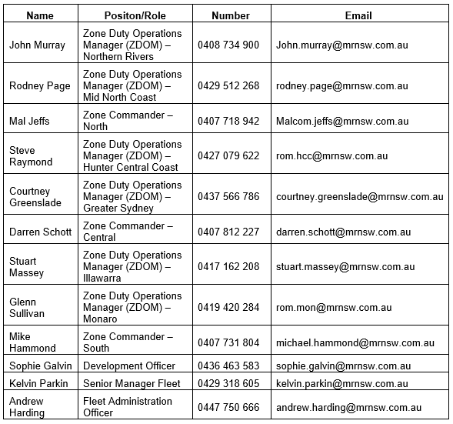

## 

## Arrival, departure and administration

Your travel details will be pre-arranged, and the details will be advised to you. Note though that this may change at the last minute due to weather conditions and flood levels.

You may need to travel via aircraft during your deployment. Please ensure that you pack considerate of airline weight limitations, and advise the MRNSW LO if you think you may need extra baggage limits booked.

## Safety, First Aid and PPE

There are many hazards associated with responding to emergencies of this nature. Everyone is responsible for ensuring their own safety and well-being, and that of the others they are working with. Please ensure you take the time to review the various Safety Bulletins that have been produced in association with your deployment - these can be found via the Member Services section on the MRNSW website. Link below;

<https://www.marinerescuensw.com.au/members/member-support/flood-response-information-for-members/>

Members need to ensure an appropriate Operational Risk Assessment is conducted as necessary for the various tasks undertaken whilst on deployment, and that a full induction is received/completed for any equipment/resources that may be unfamiliar.

Any safety issues, near misses, or incidents are to be reported as soon as practicable to the rostered MRNSW LO or staff member with you in the field, and the appropriate SES Sector Commander, or the RFS Base Camp Manager upon the site for which the incident has occurred.

There is appropriate First Aid available onsite at the RFS Base Camp through St John Ambulance.

In an emergency, please also contact Triple Zero (000).

It is recommended that members bring with them, a pair of gumboots &/or waders, long footy type socks are recommended for wearing under gumboots, a pair of rigging type/leather gloves, and where available, an appropriately fitting MRNSW PFD, and an over the head mosquito net may also be useful.

A small dry bag/day pack is helpful too.

## Sleeping and Bedding Arrangements

Your accommodation has been pre-arranged and the details will be advised to you. Note though that this may change at the last minute due to flood levels and the need to house local impacted residents.

Similarly, due to limited accommodation in the town and the number of displaced residents and emergency service personnel you may have to share a room with another person of the same gender (usually another MRNSW member).

Please ensure that you check in, and out, of your accommodation venues are per their advised requirements, and if you encounter any issues, please advise the onsite manager, and/or the MRNSW LO assisting with your deployment.

Bedding and towels are provided, however if you would like to bring your own bedding/towel, please ensure these fit within your suitcase, and within relevant airline baggage weight limits.

## Fuel, Cars and Parking

Where possible, MRNSW will endeavour to provide you with a MRNSW vehicle, or other appropriate vehicle for use during your deployment. There is adequate parking on site for all vehicles. Please confirm refueling arrangements with the local SES Sector Commander or the MRNSW LO.

For MRNSW vehicles specifically, it would be greatly appreciated if you could please keep a running log of kilometres travelled to/from and during deployments, fuel amounts added (Ls), and expense receipts kept for fuel if refuelling separately to that provided directly by SES or RFS (i.e. offsite at a fuel station).

## Food and Beverages

There are various food vendors around the town that are open. SES will also provide you with food and beverages before your deployment each day. If you need/choose to buy food for any reason please ensure you submit your expense receipt upon return from your deployment for reimbursement.

It is recommended that you pack your own food and beverage for your Day 1 travel out day.

Any special dietary requirements need to be advised in advance – please let the rostered MRNSW LO or the staff member confirming your deployment know.

## Clothing

You will need sufficient uniforms (MR blues & wet weather gear - preferably long sleeves and pants), and appropriate casual clothing (for hot and cold weather), and enclosed footwear (suitable for on vessel also), for the entire task (on shift and casual down time overnight).

Many members have found gumboots to be the most suitable form of footwear during the day, however as gumboots are not available in Brewarrina, please purchase these and take them with you if you would like to use them (retain receipts for reimbursement with your other expenses).

You may like to wear thongs in the showers.

Laundry facilities are available on site - however it’s much easier if smaller loads (i.e. no more than 2 days worth) are dropped off at any one time.

## Sanitation, Hygiene and Sun Safety

Members should ensure they provide their own personal toiletries, sunscreen, lip conditioner, antibacterial wipes, and mosquito repellent (Bushman’s 40% or 80% Deet is recommended).

Wear sunscreen! Even on overcast days, up to 80 percent of UV rays can still penetrate light cloud cover and reach your skin.

A broad-brimmed hat and sunglasses are also recommended.

## Technology

Your accommodation is a powered site to enable charging mobile phones, iPads, laptops, portable power banks, electric toothbrushes etc. However, you may like to bring a power board/adaptor for charging multiple devices at the same time. Although it is recommended that members should limit bringing unnecessary electronic devices, for security and damage minimisation.

Radio communications on site are primarily via SES supplied GRNs.

## Employment Protection Letter

SES has issued MRNSW with an Employment Protection Letter that states you were unable to attend usual work duties for the period of time that you were assisting in the floods. A copy of this letter is contained within the flood deployment documents.